**Gametogenesis – Notes**

* The process that creates the male (spermatozoa) and female (ovum) gametes.
* Gametes have the haploid (n) number of chromosomes.
* The ovum and spermatozoa join during fertilisation to form a zygote (2n).
* Spermatogenesis is the **formation of a spermatozoa** in the **seminiferous tubules of the testes**.
* Oogenesis is the **formation of ova** in the **ovary**.

**Spermatogenesis – Notes**

* Occurs inside the seminiferous tubules of each testis.
* The **seminiferous tubules are lined with** immature cells called **spermatogonia** (sperm mother cells (2n)).
* Spermatogonia (sperm mother cells (2n)) undergo **mitosis** at puberty (under the influence of follicle stimulating hormone (FSH)) so that there’s a **constant source of cells for sperm production**.
* Primary spermatocytes (2n) are **daughter cells from the spermatogonia** that **move to the centre of the seminiferous tubule** and **grow**.
* Secondary spermatocytes (n) are **primary spermatocytes that undergo Meiosis I and become haploid**. 2 haploid secondary spermatocyte cells arise from one primary spermatocyte cell.

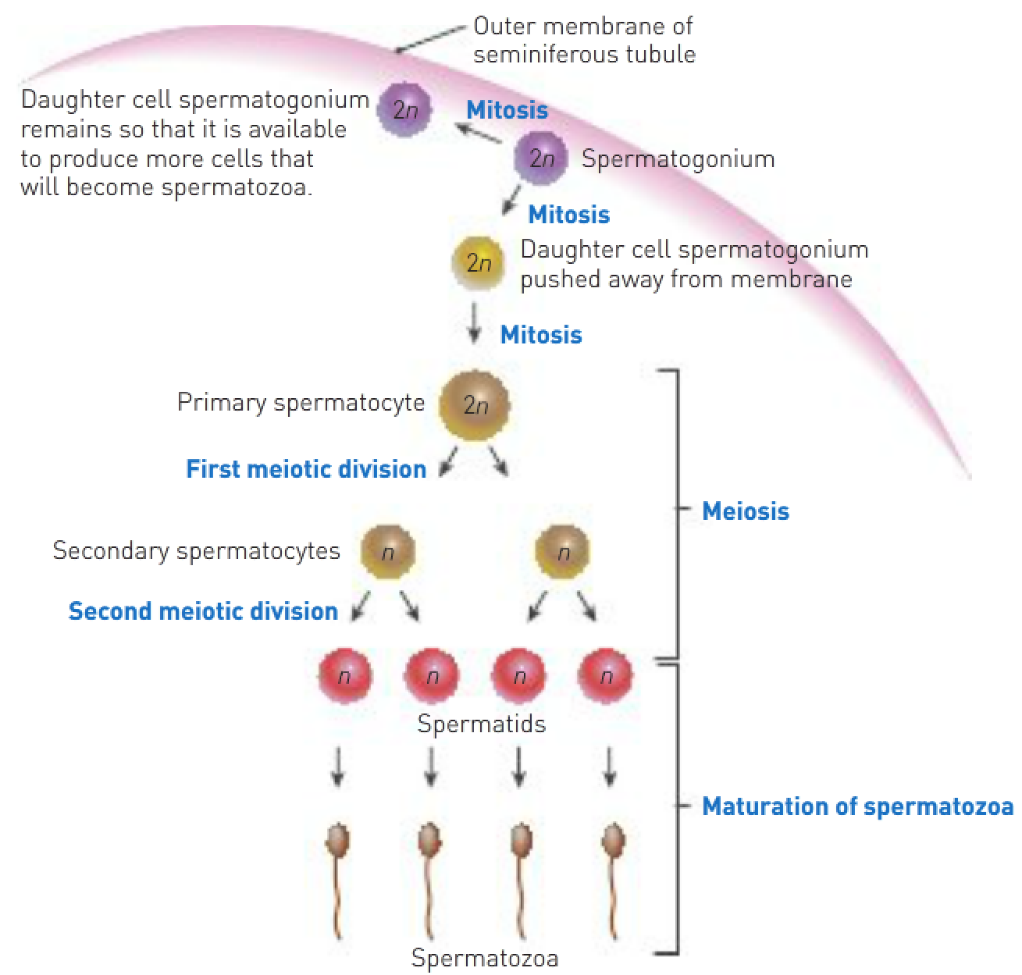

* Each secondary spermatocyte **undergoes Meiosis II and becomes 2 spermatids (n)**.
* There are now **4 haploid spermatids** (2 from each secondary spermatocyte) from one diploid spermatogonium.
* Finally, the spermatids **mature to be spermatozoa** (sperm). They **lose their cytoplasm** and **form a tail** containing contractile material.
* The maturing spermatozoa are nourished during this stage by **special cells that extend from the outer portion of the seminiferous tubule into the centre**.
* Spermatogenesis takes 72 days.

Spermatozoa:

* Have a head, neck, middle piece and tail.
* The head consists of **DNA** and a **fluid-filled vesicle at the tip** that contains **enzymes to break down the acid on the outside of an ovum**.
* The tail is necessary to allow **motility** (movement) of the sperm.
* The middle piece contains **large numbers of mitochondria** for cellular respiration to **provide energy for movement**. Seminal vesicle secretions need to provide energy because the middle piece is surrounded by only a **small amount of cytoplasm**.
* Because there’s so little cytoplasm, sperm have a **short survival period** and receive their **nourishment from the semen in which they’re suspended**.

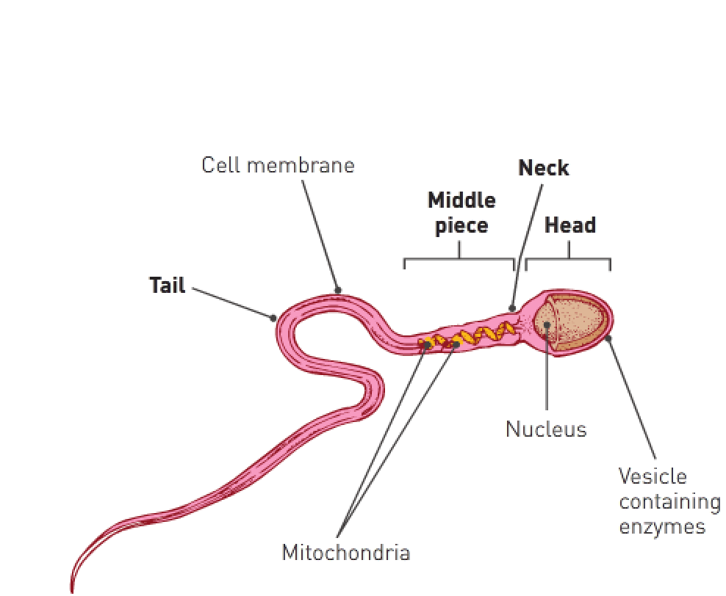

**Oogenesis – Notes**

* The production of ova within the ovary.
* Oogonia (2n(44+XX)) are diploid mother cells that eventually become ova.
* There are millions of oogonia in the female ovaries prior to the female foetus being born. They’ve been **undergoing mitosis up to this point to become primary oocytes** (2n(44+XX)).
* Primary oocytes have **undergone Prophase I and stopped at that point**; at birth they’re still at Prophase I. **Each primary oocyte is surrounded by a primary follicle**.
* At puberty, under the influence of FSH, the **primary oocyte and follicle begin to mature and grow**.
* As it matures, the **primary oocyte finishes Meiosis I** to form **2 haploid cells**.
* Of the 2 haploid cells, one **receives most of the cytoplasm** and is called the **secondary oocyte**.
* The other **receives little cytoplasm** and is called the **first polar body**. They both receive 23 chromosomes (22+X).

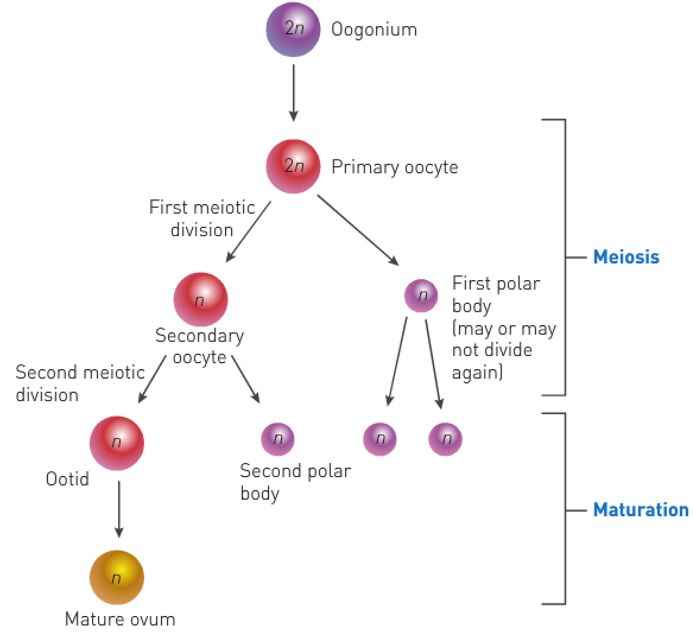

* The secondary oocyte starts Meiosis II but **stops at Metaphase II until ovulation**.
* At this stage ovulation occurs; the **follicle ruptures**, expelling the secondary oocyte and, **if penetrated by a spermatozoon, meiosis is quickly completed**.
* If expelled by ovulation, the secondary **follicle ruptures** and the **secondary oocyte with the first polar body moves from the ovary into the oviduct**. **If fertilised, the secondary oocyte completes Meiosis II rapidly**.
* If **not expelled via ovulation**, the **secondary oocyte and first polar body can go through Meiosis II**.
* This forms an **ootid (nearly matured ovum (n))** and **second polar body** from the secondary oocyte and **2 polar bodies** from the first polar body.
* The ootid (n) can become a mature ovum.
* All polar bodies disintegrate.
* **One mature ovum and 3 polar bodies** can be formed from one primary oocyte.